Walk 10 Kings Caple
Last walked in May 2019

Description. A 7 km (4.3 mile) walk along road, river and across country, with a pub in Hoarwithy. A couple of small hills to climb.
Start. Park the car outside St John the Baptist Church, Kings Caple. Explorer Map 189 Grid Ref: 559288.
Direction from Belmont roundabout (Turn milometer to zero). Take the A49 to Ross-on-Wye and after .4 of a mile, at traffic lights, you TL and head towards Holme Lacy on the B4399. At the first mini roundabout (.6 of a mile) TR to Hoarwithy. At 7.2 miles, just before entering Hoarwithy, TL to King’s Caple. About ½ mile further on, at 7.6 miles you TR, signed to Ruxton, and drive along a single lane road to the church. Total distance is 8.5 miles.

1. St John the Baptist Church, Kings Caple. The churchyard stands on the bailey of a Norman castle, whose motte, known as Caple Tump, stands across the road. This road was part of a Roman road called Caple Street. In the gallery stands the Benefactions Board from 1796; this shows the six charities established for the Poor by local landowners and their tenants. An unusual one is called Cake Money by which Pax Cakes are still distributed every Palm Sunday to the congregations of this church. The church has six bells, the oldest dating from 1632. Park on the grass by the tump opposite the 13th century St John the Baptist Church, (a tump is a small rounded hill or mound). From the road go around the R hand side of the tump to a stile in the fence on your R. Climb over the stile and cross a track to climb over another stile into a field F1. Walk straight across the field to go thru a metal gate/kissing gate onto the Sellack Boat Road, and TR. Continue on, passing a house called Shieldbrook, which is on your L, and keep on until the road turns sharp L. Continue straight on, thru the middle field gate onto the enclosed mud track to cross a footbridge over the river Wye.

2. Bridge over the River Wye. Before continuing, turn R and go under the bridge to read the memorial commemorating this link between Kings Caple and Sellack. The bridge, put up in 1895, brought to an end the centuries old ferry between the parishes. From the footbridge continue straight across the fields, heading towards the church at Sellack. You cross over a small wooden footbridge, and continue on to cross over a stile into F2. Cross the field to reach a stile by a metal gate. If you want to visit the 13th century church then cross over the stile in front of you, else cross over the stile on your R, into F3. Sellack church is dedicated to St. Tysilio and claims to be the only English church dedicated to a Celtic saint. Head diagonally across the field towards the river, and on reaching the river you TL and continue along the riverbank. Cross over a stile, which is on the R of a double metal gate, and continue along the river bank, passing a smart looking fishing hut by the edge of the woods on your L. Keep to the edge of the wood on your L as it veers away from the river, at the end of the wood you continue on, to cross over a stile that’s in the middle of metal gates and onto a road.

3. Kynaston, Hentland. Take the road opposite, signposted Kynaston, Hentland, and continue uphill for a kilometer until it turns sharp L. TR and walk along the enclosed Public Footpath. Continue along this track for 200 meters, then ignore the track as it bends around to the L and walk straight on down another enclosed track, to go underneath electric cables. The enclosed track descends a little as it bends to the R and after 150 metres you go thru a metal kissing gate into F4. Continue along the L field edge; keep to the fence/hedge on your L and go thru a metal kissing gate into F5. Continue along the L field edge to go thru another metal kissing gate, to cross over a farm track and into F6. Keep to the L field edge, there are power cables above that you can follow. Walk along the edge of this large field that eventually descends to its far corner, where you climb over a stile into a wooded area. Walk straight on to climb over another stile/metal gate onto a concrete drive. Continue in the same direction to walk down an enclosed track that’s to the L of a double garage and a house called ‘Quarry Bank’. Walk down the track that descends thru trees to reach a main road.

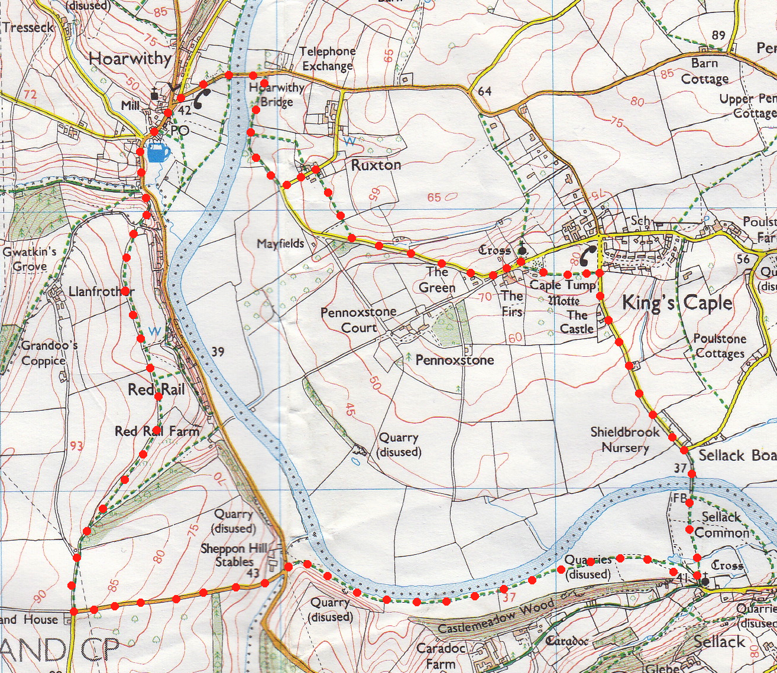
4. Road to Hoarwithy. Bear slightly L and walk with care along the road into Hoarwithy. Walk past the New Harp Inn on your R and take the first R turn signposted Kings Caple 1, (the church of St Catherine is on your L). The church is not always open but there are splendid views from the terrace. The original chapel was built in 1840. The interiors are sumptuous, modelled after the Cathedral at Le Puy, in France. The centrepoints are the white marble altar studded with precious stones and a similar white marble pulpit with panels of green porphyry. Continue along the road passing the tollhouse on the bridge over the Wye. After crossing the river bridge you walk towards the Kings Caple sign (R), and just before the sign, TR, to walk along a dirt track that runs parallel to the river.
5

5. Ancient road. Walk along this track, which widens to the ancient road it once was, gradually getting closer to the river. Ignore the stile and footpath sign on your L. The track bears L away from the river to join the road. Turn L and walk past the entrance to Lower Ruxton Farm on the L. Just before the white cottage on your R, TR onto a stone track. Keep to the L of the black corrugated barn, and go into F7. Walk straight across F7 to cross over a stile into F8. Go straight across F8 to cross another stile onto the road. TL, and walk up the winding road, as you pass the large house on the R called The Green, the road bears L. Follow this to the next junction and bear L. Ahead is Kings Caple church.
1
4
2
3

